

ICT Lab
BS CYFS 2025
Lab Task 14
Name: Muhammad Asfand Yar Arshad
Roll no: 2503543

Submitted to : Mrs. Laraib Javaid

Table of Contents
Practice Task: 1 3
Practice Task: 2 3
Practice Task: 3 : Alert : 3
Practice Task: 4 : Confirm: 4
Practice Task: 5: PopUp: 5
Practice Example: 6
Lab Task 1: 7
Lab Task 2: 8

Practice Task: 1
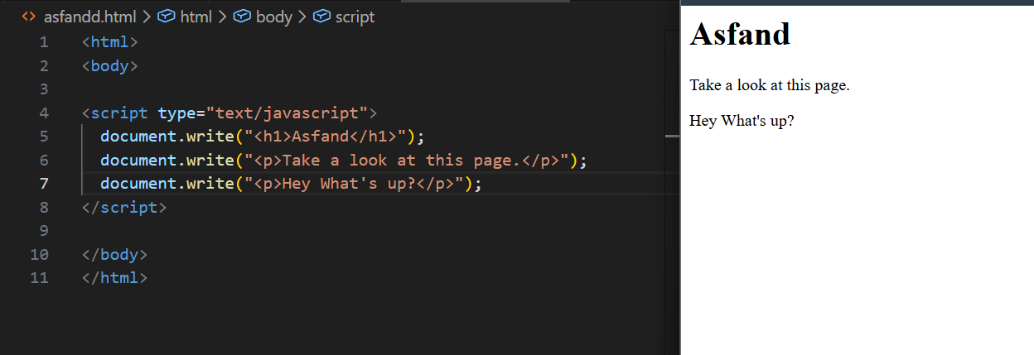

Practice Task: 2
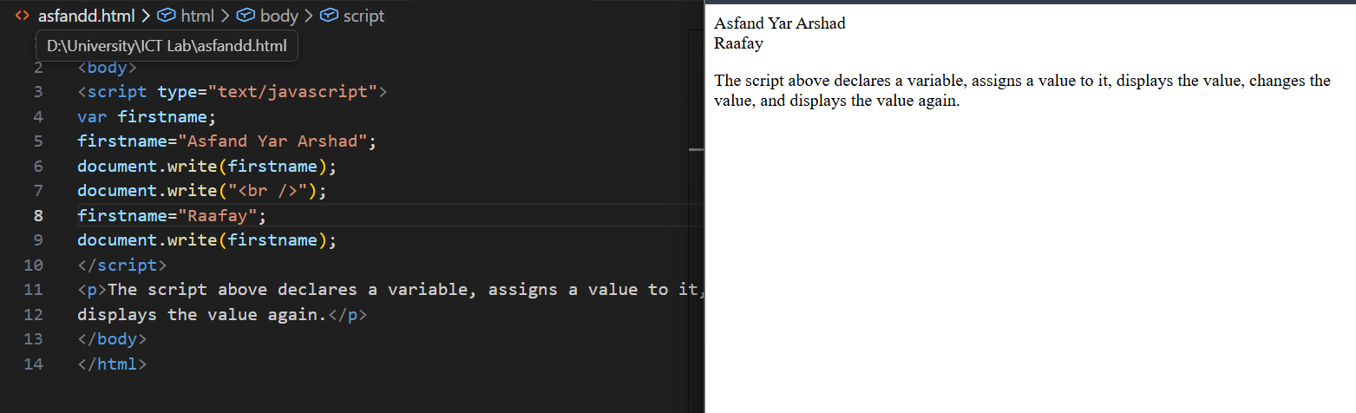

Practice Task: 3 : Alert :
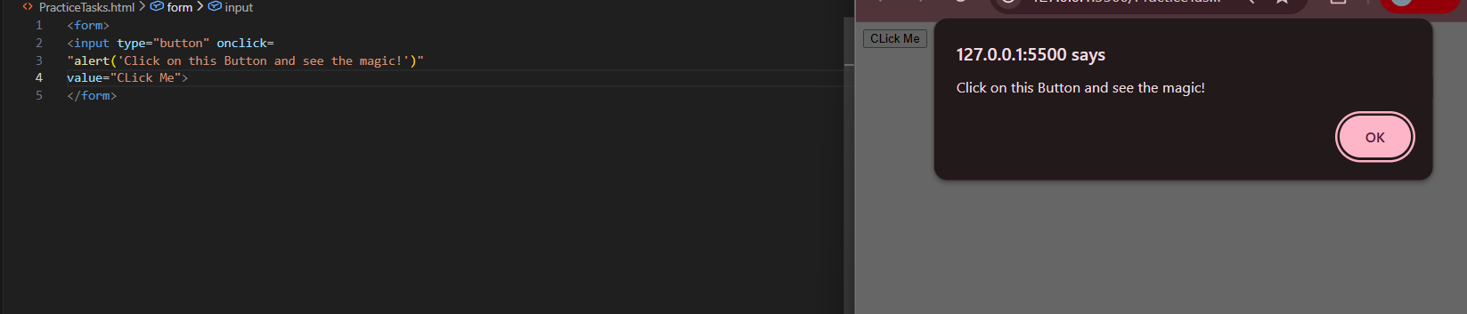

Practice Task: 4 : Confirm:
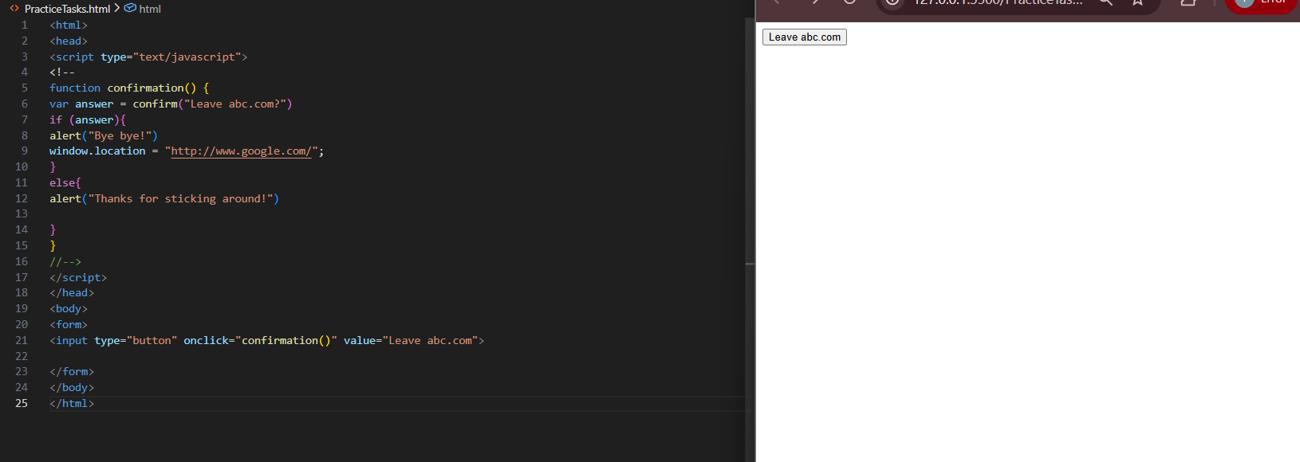
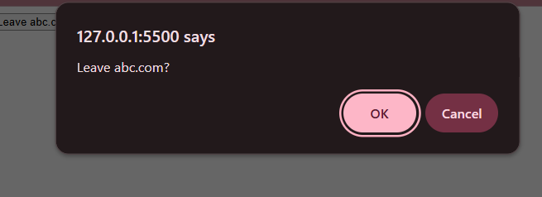
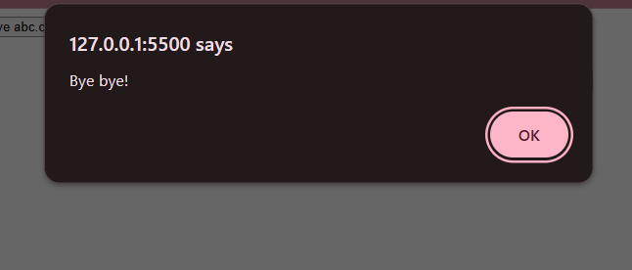 It Directs us to the page:


Practice Task: 5: PopUp:
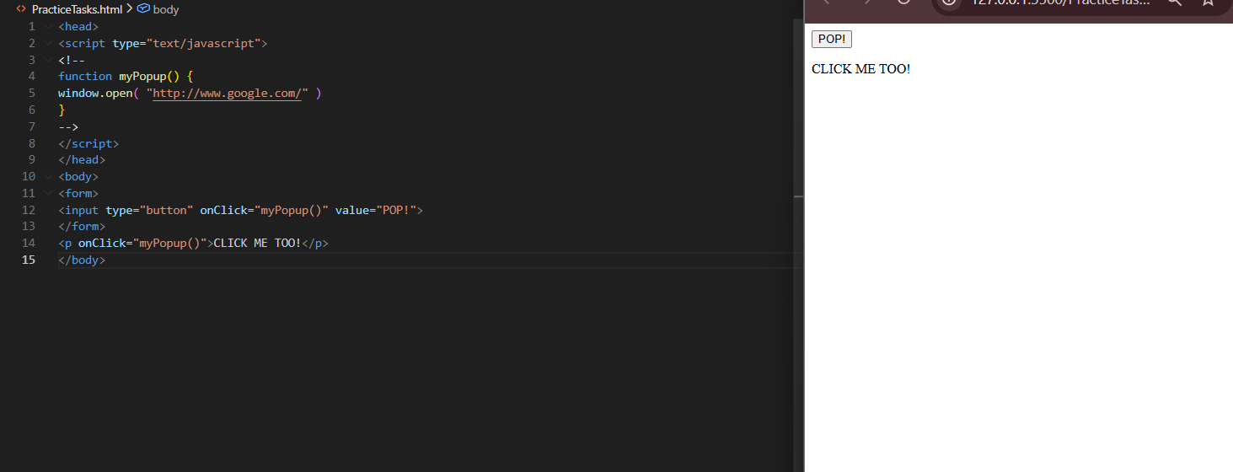


Practice Example:
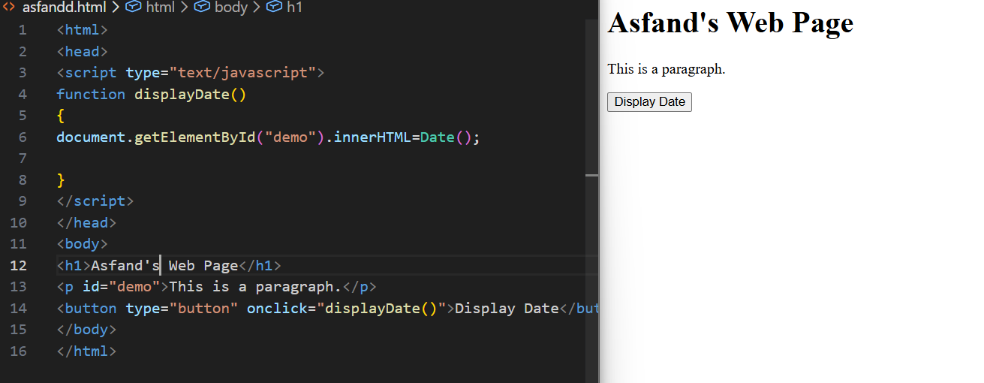

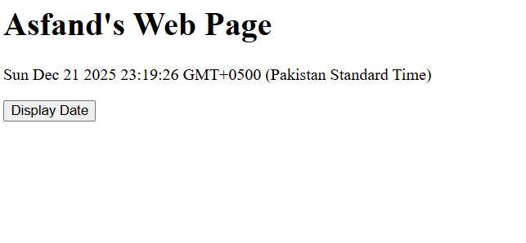Lab Task 1:
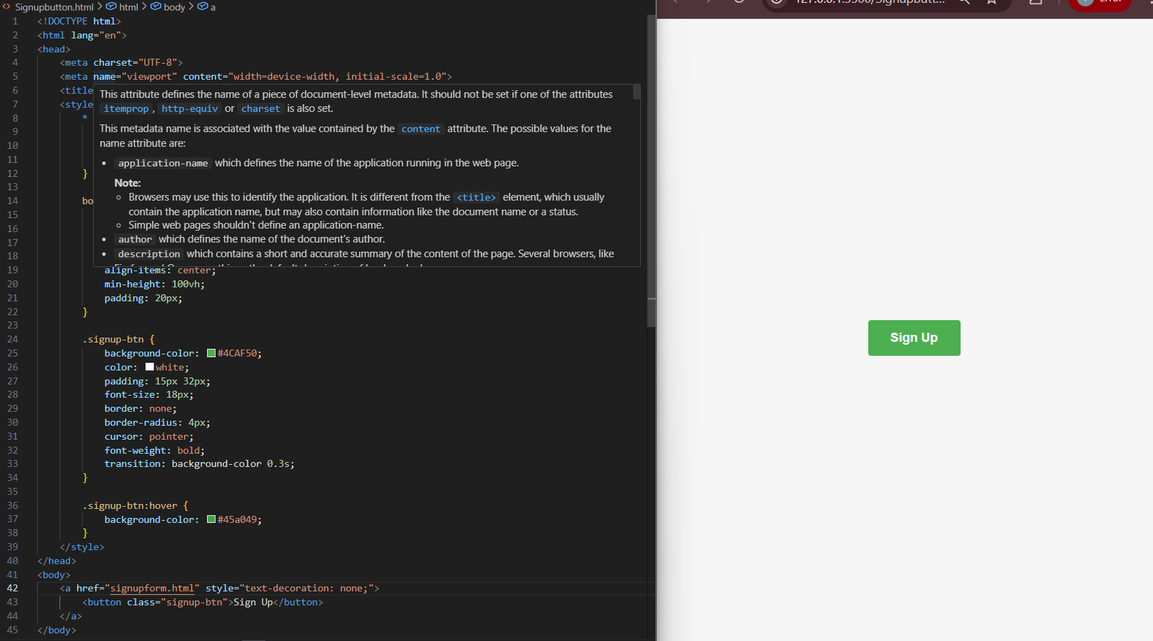

Lab Task 2:
